A1099-Indus-Balochistan-Kulli Mehi Culture-Dish-N­aga Design-2500 BCE

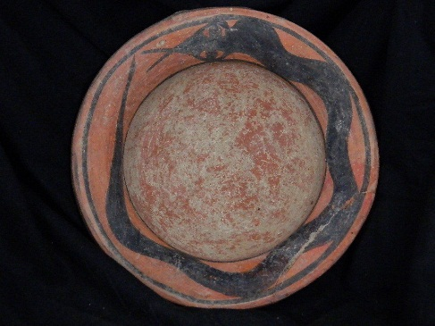 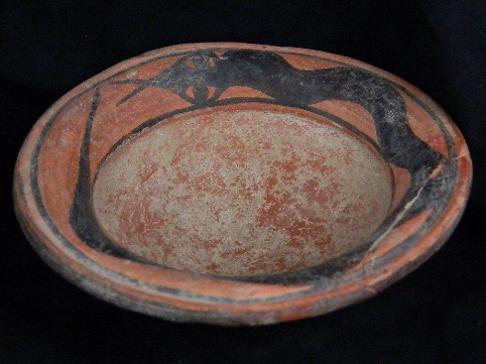 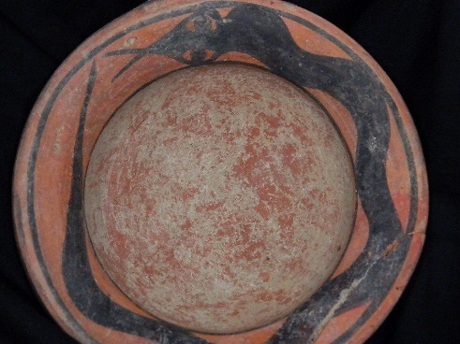

**Formal Label:** Indus-Balochistan-Kulli Mehi Culture-Dish-N­aga Design-2500 BCE

**Case no.: 3**

**Accession Number: A1099**

**Formal Label:** Indus-Balochistan-Kulli Mehi Culture-Dish-N­aga Design-2500 BCE

**Display Description:**

Kulli-Mehi Culture Ceramics dating to the “mature” Harappan Period, 3A (Harappa A Phase) c 2500 BCE are characterized by fine-line, linear black painting over a pinkish or buff ground, with an occasional dark red vertical or horizontal band dividing motif zones. The Kulli-Mehi group is divided into two distinct types based on the style of decoration: 1) purely geometric designs and 2) geometric designs combined with stylized animals and plants. It is probable that the second type developed out of the first. Animal and plant motifs are comparable to Nal culture types.

Kulli Mehi Culture figurines are mostly made from molds. Brahman bull figurines are portrayed with elongated bodies, curved horns, powerful muzzles, and disproportionately large, round eyes.

**LC Classification:** DS425

**Date or Time Horizon:** 2500 BCE

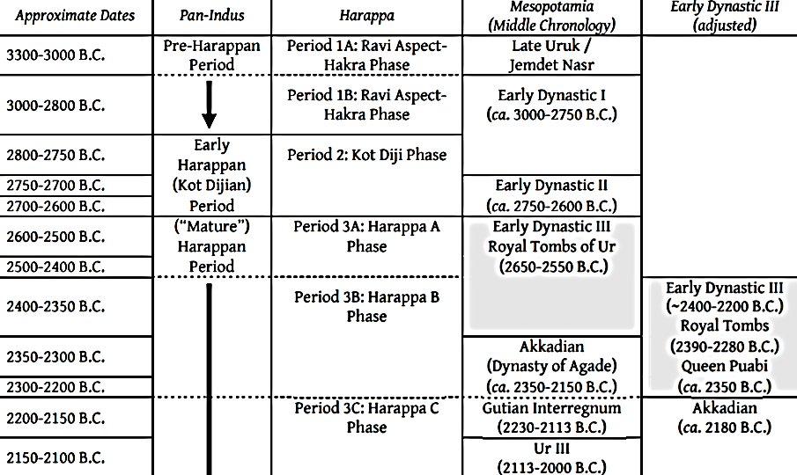

Fig. Comparison of the chronologies of the Indus Civilization Cultures and Mesopotamia (after Lamberg-Karlovsky & Sabloff 1995; Meadow, Kenoyer & Wright. 1998; 1999; 2001; Postgate 1995).

**Geographical Area:** Indus Valley

**Cultural Affiliation:** Indus Civilization

**Medium:** Terracotta

**Dimensions: Dia. 142.25 mm ; 5.60 in  
Weight: 7.25 oz, 208 gm**

**Provenance: Ex European Collection, 1969-2016.**

**Condition:** Fractured rim segment, re-attached

**Discussion:** The Sanskrit word *Naga* has its root *nag* the word for “serpent”. In Indian mythology, Nagas are primarily sub-marine serpent-beings. The encircling Naga is an emblem of the amphisbaenic serpent that resurrects itself by shedding its skin periodically. It symbolizes, in Jungian psychological terms, the regeneration of a new trans-personal self from the limited ego. The Naga is distinguished from the traditional interpretations of the serpent in the Garden of Eden myth: the emergence of the new enlightened self is distinguished from self-knowledge as a transgression against Yahweh. This juxtaposition of the Indian Naga and the Biblical serpent distinguishes Eastern spiritual enlightenment and Judeo-Christian sin against Yahweh.

This bowl may have been used in a ritual context that contained sanctified water that conferred upon the acolyte the blessings of the amphisbaenic Naga in the unfolding of the trans-personal self. In Hindu mythology this is expressed as the self-sacrifice of the primordial being (the Naga in this case) for the sake of creating the world. This parallels the self-sacrifice of “the christ” or “the anointed-one” for the salvation of humanity (see Elder 2012: 46). Of course, in Christianity sanctified water is conferred upon the acolyte in the Eucharist.

**References:**

Bar-Yosef, O. and Richard, H., Meadow. 1995. The origins of agriculture in the Near East. *Last hunters, first farmers*, pp.39-94.

# Dani, A.H. and V.M. Masson. 1999. *History of civilizations of Central Asia. 1, The dawn of civilization : earliest times to 700 B.C.* Delhi : Motilal Banarsidass.

Elder, George R. 2012. *The Snake and the Rope: A Jungian View of Hinduism*. Indianapolis, IN: Dog Ear Publishing, LLC.

Lamberg-Karlovsky, C.C. and Sabloff, J.A., 1995. *Ancient Civilizations: The Near East and Mesoamerica*. Waveland Press Inc.

Meadow, R.H. and Kenoyer, J.M., 2001. Excavations at Harappa 2000–2001: New insights on chronology and city organization. *South Asian Archaeology*, pp.207-226.

Meadow, R.H., Kenoyer, J.M. and Wright, R.P., 1999. Harappa Excavations 1998. Report submitted to the Director-General of Archaeology and Museums, Government of Pakistan.

Postgate, J.N., 1995. Royal ideology and state administration in Sumer and Akkad. *Civilizations of the Ancient Near East*, *1*, pp.395-412.

# Semeka-Pankratov, Elena. 1979. “A semiotic approach to the polysemy of the symbol Naga in Indian mythology,” *Semiotica* 27(1979)1/3: 227 – 289.